Statechart Diagrams

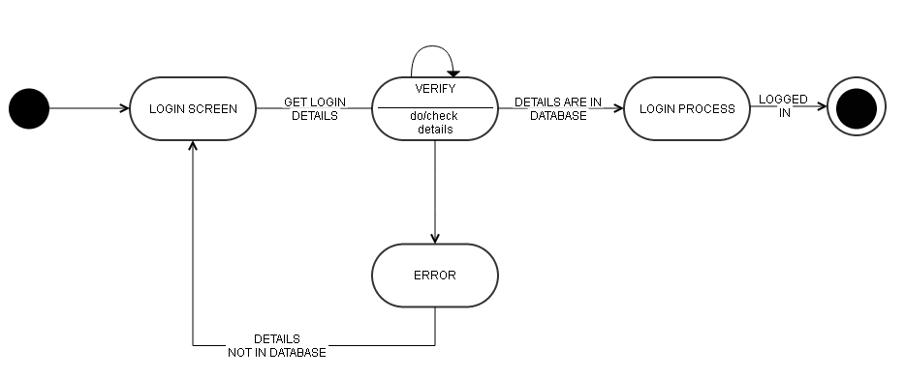

Figure : Diagram 1

*Note: this is just an example. Replace it with appropriate diagrams*